Joel Edwards
Course: Java Programming 1
Homework 1
April 7, 2011

A.3)

Source:

HelloWorld.java:
class HelloWorld {
static public void main(String args[]) {
System.out.println("Hello " + args[0]);
}
}

Output:
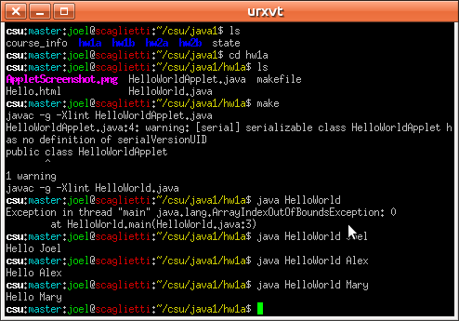

A.4)

Source:

Hello.html:
<html>
<head>
<title>A Simple Program</title>
<meta http-equiv="pragma" content="no-cache" />
</head>
<body>
Here is the output of my program:
<applet code="HelloWorldApplet.class" width="150" height="175">
</applet>
</body>
</html>

HelloWorldApplet.java:
import java.applet.Applet;
import java.awt.Graphics;

public class HelloWorldApplet
extends Applet
{
public void paint(Graphics g) {
g.drawString("Hello World!", 50, 25);
g.drawString("Good bye World!", 50, 50);
}
}

Output:
